Subject: Try the Spanish version of Fidelity NetBenefits


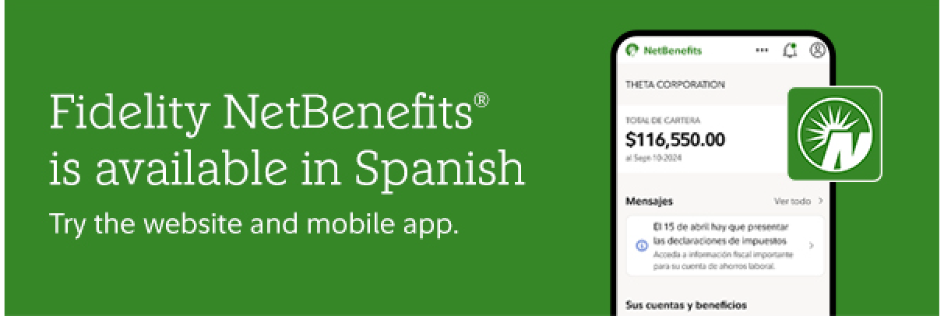



When you use NetBenefits.com and the NetBenefits® mobile app in Spanish, you can:
- Manage your accounts
Confidently change contributions and check your balance
- Build your knowledge
Quickly access educational materials on a range of topics
- Check your progress
Easily track your plan and goals with translated tools and resources

Download the NetBenefits app for more ways to access and manage your employee benefits.

Privacy Policy | Terms of Use

The information in this email is intended solely for the attention and use of the named addressee. This message or any part thereof must not be disclosed, copied, distributed, or retained by any person without authorization of the addressee.

Investing involves risk, including risk of loss.

Screenshot is for Illustrative Purposes Only.

There may be pages that have not been translated.

Please do not respond to this email. This mailbox is not monitored, and you will not receive a response. NetBenefits and the Fidelity Investments logo are registered service marks of FMR LLC.
Fidelity Brokerage Services LLC, Member NYSE, SIPC, 900 Salem Street, Smithfield, RI 02917

© 2026 FMR LLC. All rights reserved. 1239853.1.0

